**JDK (Java Development Kit)** A software development environment that provides tools for writing and executing Java programs. The compiler converts Java code into bytecode.

**JRE (Java Runtime Environment)** provides an environment for running Java programs on a machine. It includes libraries that are necessary for execution, as well as extra files and classes.

**JVM (Java Virtual Machine)** The runtime environment that executes Java bytecode, making Java applications platform-independent. It's a fundamental part of both JDK and JRE, and Java programs can't run without it.

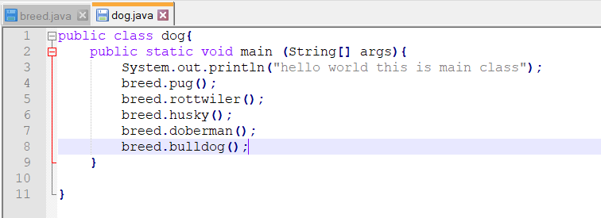

**Here,**

public – access specifier

static- non access specifier

void- returntype (returns no value)

**main**- is the *name* of the *method* used within the class of java where it can be any name but the method **main** in it can only be executed without an errors

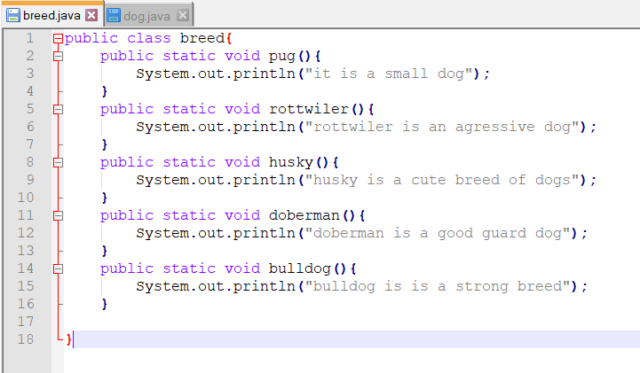

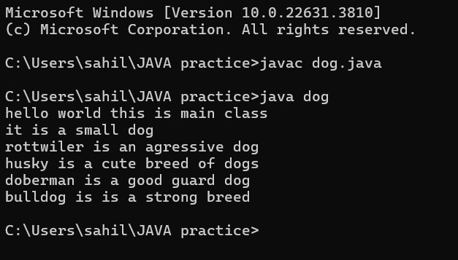

Always name the class starting from **caps** then save the file name same as class name

**public static void main (String [] args) {**

**}**

Here in main class for execution use the (String [] args)

**System** is a pre-defined class that Java provides us and it holds some useful methods and variables.

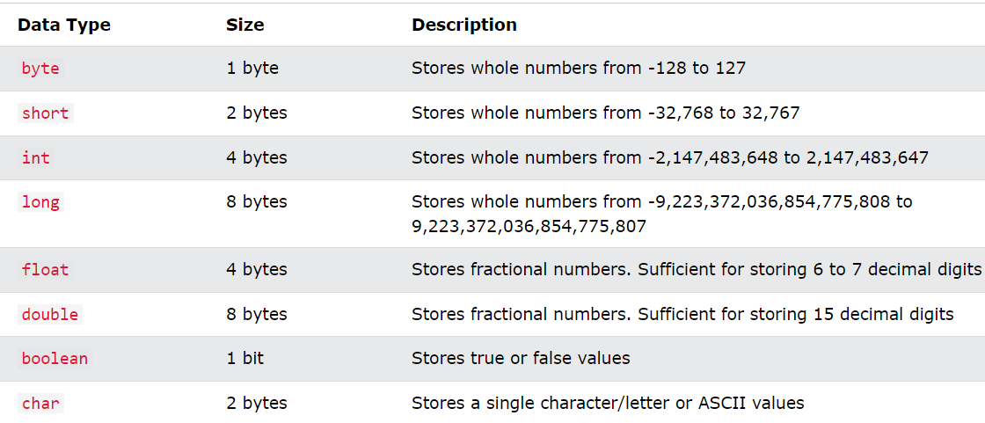

(declaring a variable in java) **type variableName = value;**

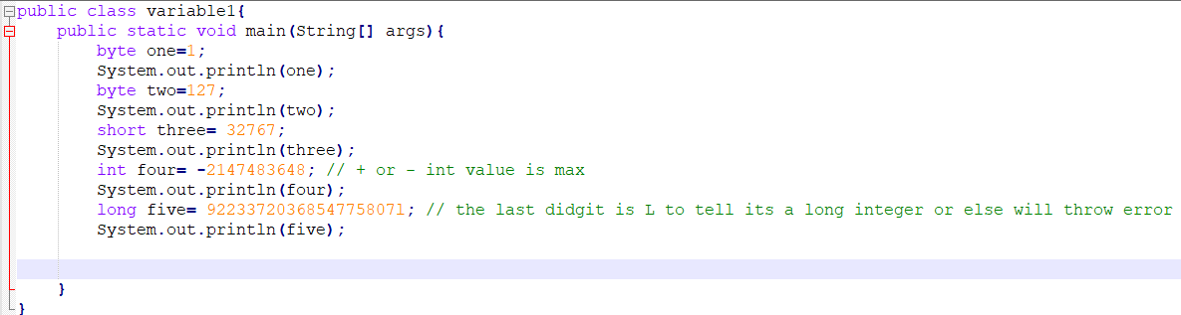

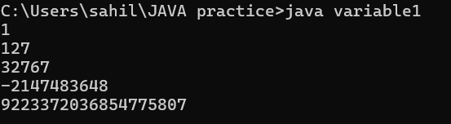 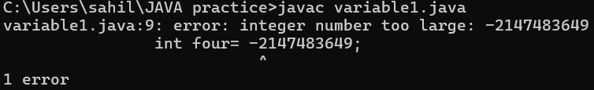

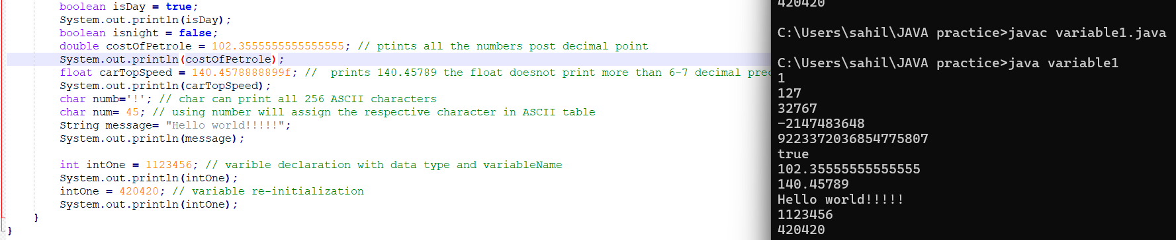

**Primitive/Non-Primitive data type**

Int , float ,char , Boolean are primitive cause they are built into programming language itself.

Whereas non primitive is user defined like class, string ,array.

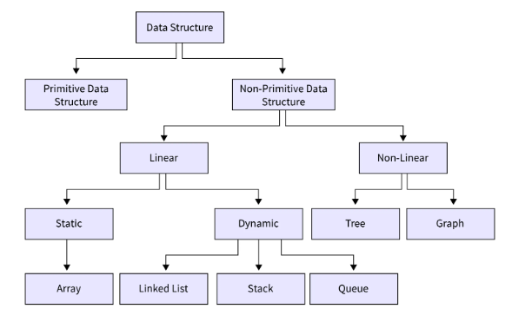

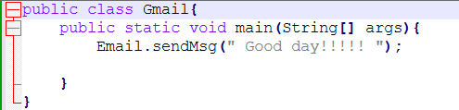 **Main class send Parameters to Email class of sendMsg method.**

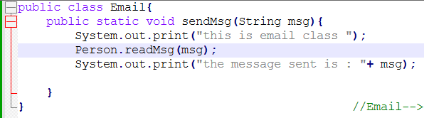**Email class receives the parameter form main class to msg argument. Then it sends the mgs data location to Person class of readMsg method.**

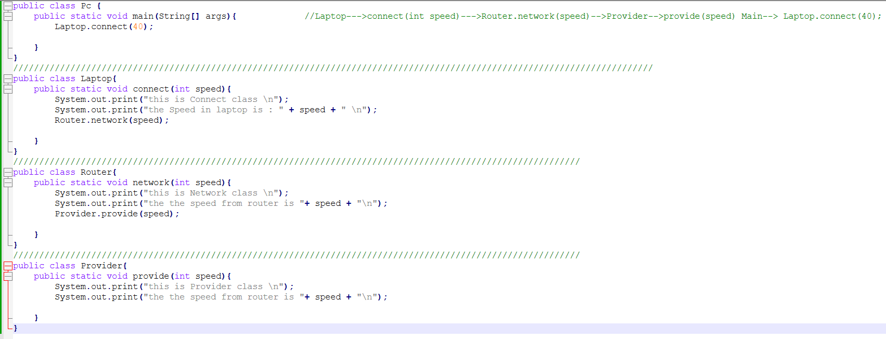

**The above code wont work cause every class must have different file. But except that the code is correct.**

